Neha Saxena 
+919910933803
neha9174@gmail.com
Add: B-Block1/18, New Ashok Nagar Delhi

Objective

- To use my knowledge, improvise skills and abilities in a progressive organization that, motivation and teamwork, to be part of a team that dynamically works towards the growth of promotes learning the organization and thereby gain satisfaction and to prove myself, which in turn helps in the growth of the organization.

Work Experience

Organization | Designation | Duration
Avalaya India Pvt. Ltd | HR Executive | 13 June 2016 till date
Toshi Industries | HR Assistant | 3 June 2013 to June 2016

Experience Breakup over a span of 3 Years

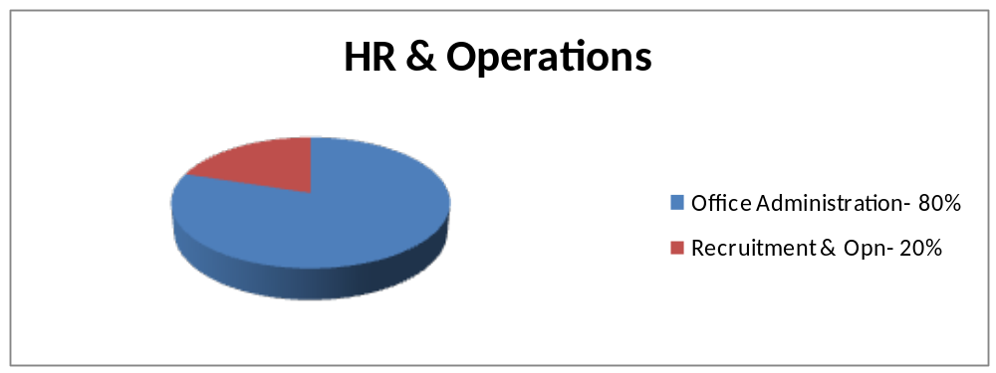

Skills ( How I can contribute?)

Exposure to entire Hire to Exit Cycle and Office Administration

- Coordinating with the candidates and HR during Walk-In Interviews
- Record and file's maintain
- Leave & attendance, Implementing HR policies, Induction, Employee engagement, Employees grievance, Performance appraisal,
- Short listing resumes from jobsites, Arrangements of Interviews round
- Joining formalities
- Employee Relation Management
- Appraisal and Performance review management
- Understanding of HR Processes & Policies
- Handling Employee Queries and Grievances
- Operation Management and administration related to - Reporting to work, Recording of time, Working hours, Salary, Overtime, Holidays,
- Collection of Data, Maintain Office Discipline
- F&F Settlement

Software Skills

- MS Office :-MS-Word, MS-Excel, MS-PowerPoint. Internet keyword relevant search
Strengths

- Punctuality, Team Player, Quick Learner and Good motivator.
Education Background

Degree | Institute | Year | Aggregate
MBA ( HR & Finance) | ANA Bareilly UPTU | 2013 | 63%
BA | NAKPPG College CSJM University Kanpur | 2011 | 59%
XII | UP Board Allahabad | 2008 | 54%
X | UP Board Allahabad | 2006 | 57%

References
Name | Designation | Contact
C K Saxena | Proprietor, Toshi Industries, New Delhi | 9810956491
Deep Krishna | Managing Director, DKG Labs , IT Company, www.dkgrouplabs.com , New Delhi | 9810124321, deep@dkgrouplabs.com
Prateek Dwivedi | Professor, Accurate Mgmt Technology, Noida | 9015092375,  dwivedi.pratik@gmail.com

Personal Details

- Father’s Name :- Mr. RatneshSaxena.
- Date of birth :- 12th July 1992.
- Marital status :- Unmarried.
- Nationality :- Indian.
- Gender :- Female.
- Language known :- Hindi & English.
- Permanent Add. :- Kadri Gate Farrukhabad U.P.

Deceleration

- I hereby declare that the above information mentioned by me is true to best of my knowledge.

Date :-
Place:- New Delhi [NEHA SAXENA]

